**RAAYAT ISLAMIC NUR & PRIMARY SCHOOL**

**MID-TERM ONE EXAMINATION, 2024**

**LITERACY 1 A – P.1**

**TIME: 2HRS 15 MINS2023**

CLASS P.1 ENGLISH JUNIOR SCHOOL

AND DAYCARE CENTRE

MID TERM ONE EXAMINATION 2023

CLASS P.1 ENGLISH

**Name: ____________________________________________**

**1. Name the sense organ.**

**______________________________**

**2. Mention two things we eat.**

**i)___________________________ii)______________________________**

**(stone, fish, book, eggs)**

**3. Draw.**

|  |  |  |
| --- | --- | --- |
| **cat** | **cow** | **snake** |
|  |  |  |

**4. How many do you have?**

**fingers _______________________________________________________**

**legs __________________________________________________________**

**mouth ________________________________________________________**

**head _________________________________________________________**

**eyes __________________________________________________________**

**( two, ten, one)**

**5. A ___________________________ treats sick people.**

**(doctor, policeman)**

**6. Name two things we use to clean our bodies.**

**i)_______________________________ii)______________________________**

**7. Tick things we wear.**

**star , short , dress , vest**

**8. Draw:**

|  |  |  |
| --- | --- | --- |
| **Pineapple** | **mango** | **banana** |
|  |  |  |

**9. Fill in the missing letters.**

**___ye b___na___a f__re**

**10. Circle ways of cleaning our bodies.**

**By crying By bathing By brushing our teeth**

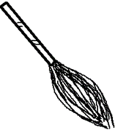**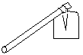11. Name these garden tools.**

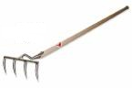 **____________________ _________________**

**____________________**

**(bucket , broom, rake, hoe)**

**12. Match to their senses.**

**eyes feeling**

**nose tasting**

**ear seeing**

**tongue smelling**

**skin hearing**

**13. A cow has ________________________ legs. (two , four)**

**14. Name these parts.**

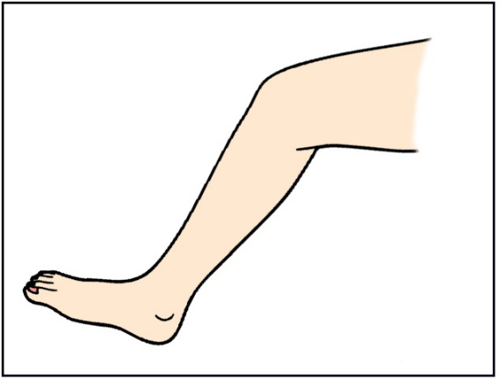

**a**

**a ____________________ heel**

**b ___________________ knee**

**b c c ___________________ toes**

**15. Tick common insects.**

**broom butterfly bee**

**16. Match and draw.**

**razorblade nail**

**fire razorblade**

**nail fire**

**17. We wash our hands to ___________________ germs.**

**(beat , remove)**

**18. Complete correctly.**

**I use a _________________________ to brush my teeth.**

**I use a _________________________ to bathe.**

**(broom , toothbrush , sponge )**

**19. Tick common diseases.**

**ear malaria diarrhoea dog**

**20. Name any three body parts.**

**i)_____________________________ii)______________________________**

**iii)____________________________**